

EXAMPLE SCHOOL NEWSLETTER TEXT AND GRAPHIC
…………………………………………………………………………………………………………………………………………………………….

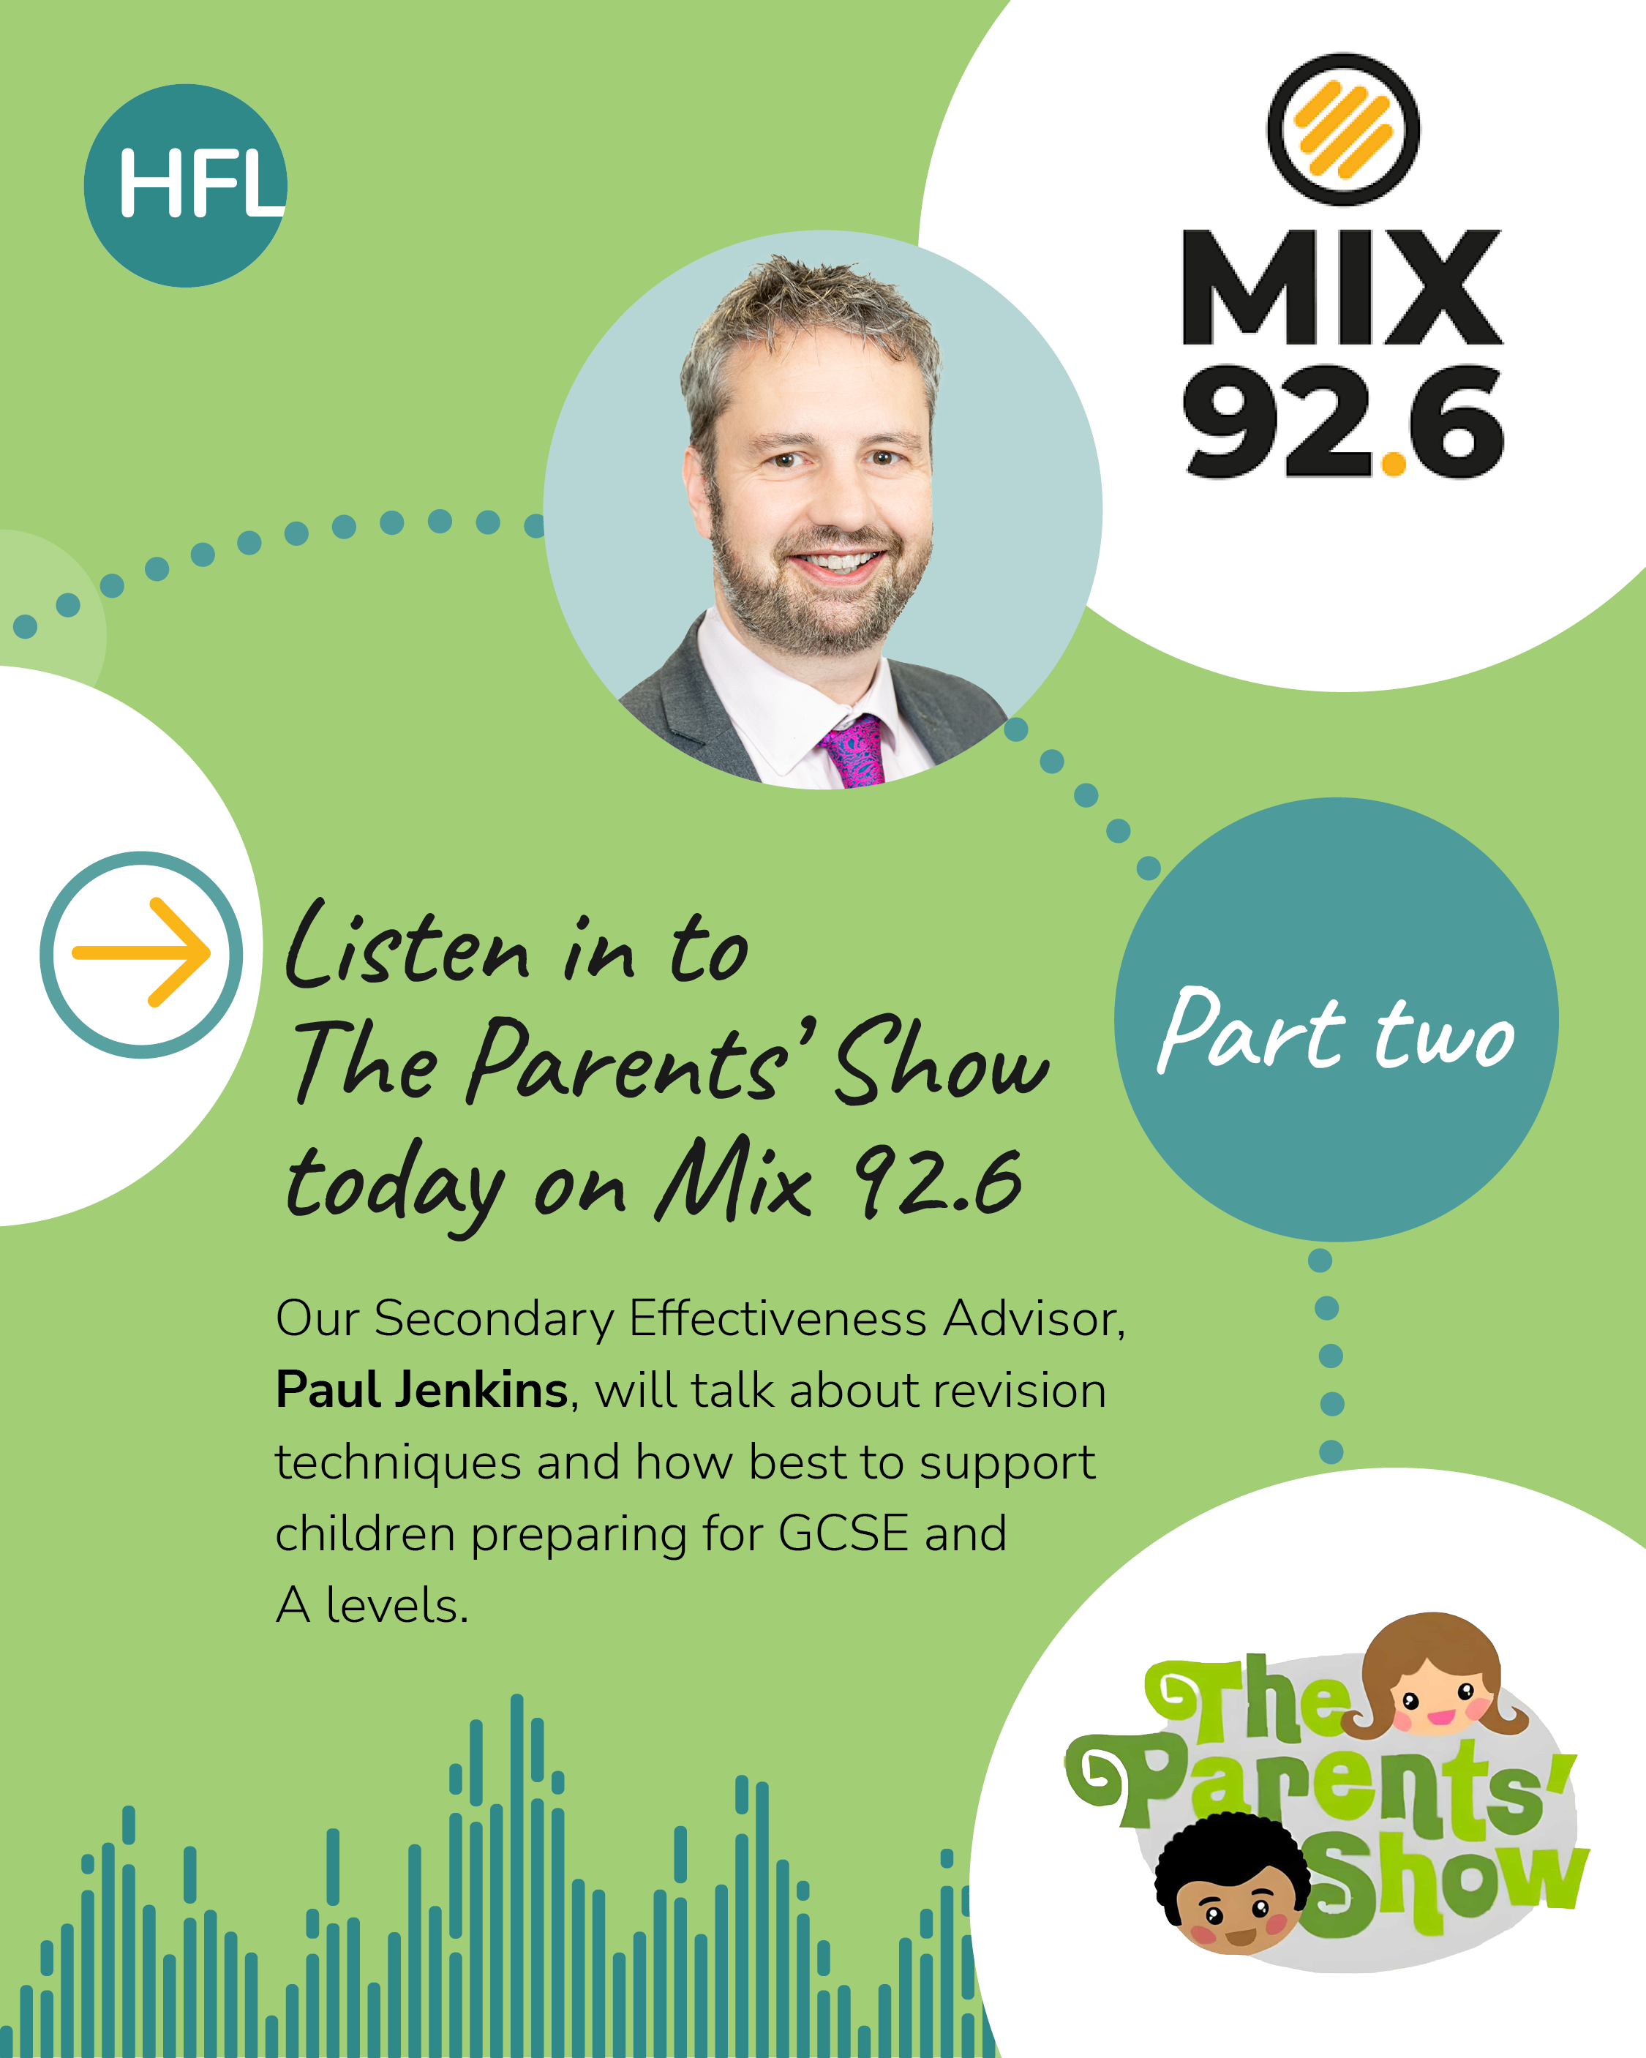
Practical advice on supporting teenagers through GCSE and A level revision

Exam preparation can be a stressful so take time to listen to this informative interview which focuses on how parents can help young people revise effectively while protecting their emotional wellbeing and avoiding unnecessary pressure.

Produced by Herts Mix 92.6 Parent Show with Paul Jenkins, an experienced secondary educator, it provides great tips on how to support your children at home. Listen here

This interview is one of a series recorded which you might find helpful. All episodes are available on Spotify here.
……………………………………………………………………………………………………………

