

SAMPLE TEXT AND GRAPHICS TO SHARE THE PARENT SHOW
INTERVIEWS YOUR SCHOOL NEWSLETTERS
…………………………………………………………………………………………………………………………………………………………….
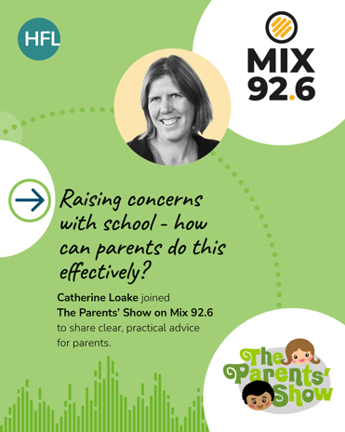
Raising issues
We are proud of the collaborative relationship we have with our parents, but we know that sometimes there are concerns you might need to raise with us. This radio interview provides actionable tips for getting the best out of what can be difficult conversations. Listen here.

This interview is one of a series recorded with HFL Education, an organisation we work with, but all episodes of the parent show are available on Spotify here.

…………………………………………………………………………………………………………………………………………………………….

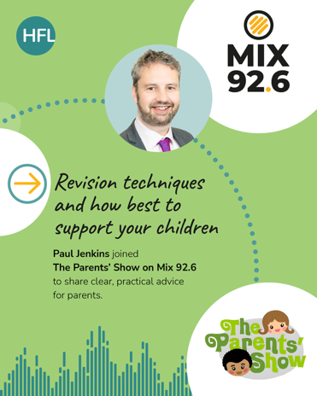
Supporting children preparing for GCSEs and A-levels
GCSE and A-level preparation can be a stressful time for students and parents can feel helpless. This radio interview on the Mix 92.6 Parent Show with an experienced secondary educator provides some great tips on how to support your children at home. Listen here

This interview is one of a series recorded with HFL Education, an organisation we work with, but all episodes of the parent show are available on Spotify here.
……………………………………………………………………………………………………………

