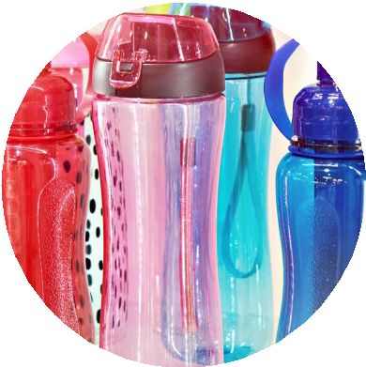
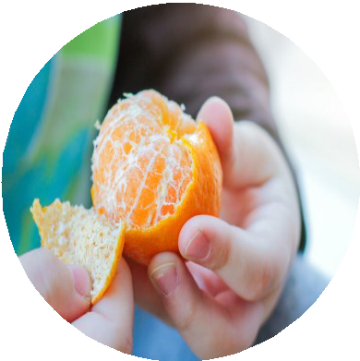
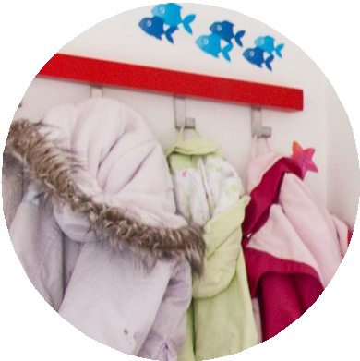
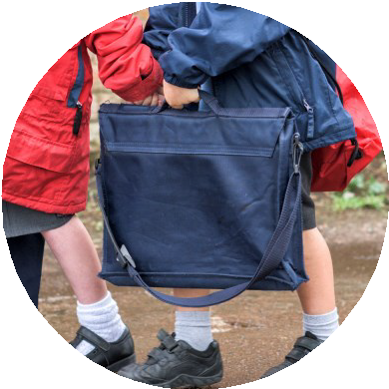
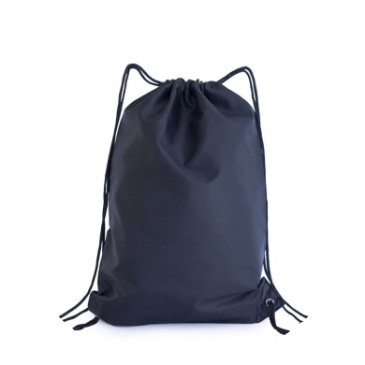
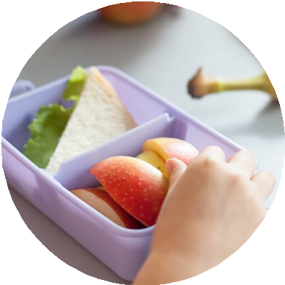
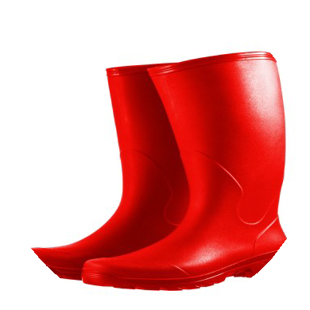
COAT
SNACK
WATER BOTTLE
53.1
Supporting Smooth Transitions | 2025-26
MY CHILD’S FIRST DAY AT SCHOOL
TOP TIPS
Make sure your child’s name is on all of their belongings and show what it looks like

Show your child where to put their belongings (coat, bottles, lunch box) but encourage them to put it away them to put it away themselves

Smile! We know it can be difficult to leave your child but they are safe and will have a lovely time with us in school
Collect from here:

Drop of here:

(insert photo)
(insert photo)
The date of my child’s first day

Finish time:

Start time:

BOOK
BAG
P.E. KIT
(optional)
LUNCH BOX
(optional)
WELLIES
(optional)

