COHORT PLANNER TO SUPPORT TRANSITION LEVEL OF NEED

Use the table to plan transition for groups of or individual children. Indicate the types of activities or events that you
plan to offer and add information about which children this will be offered to. See example below:

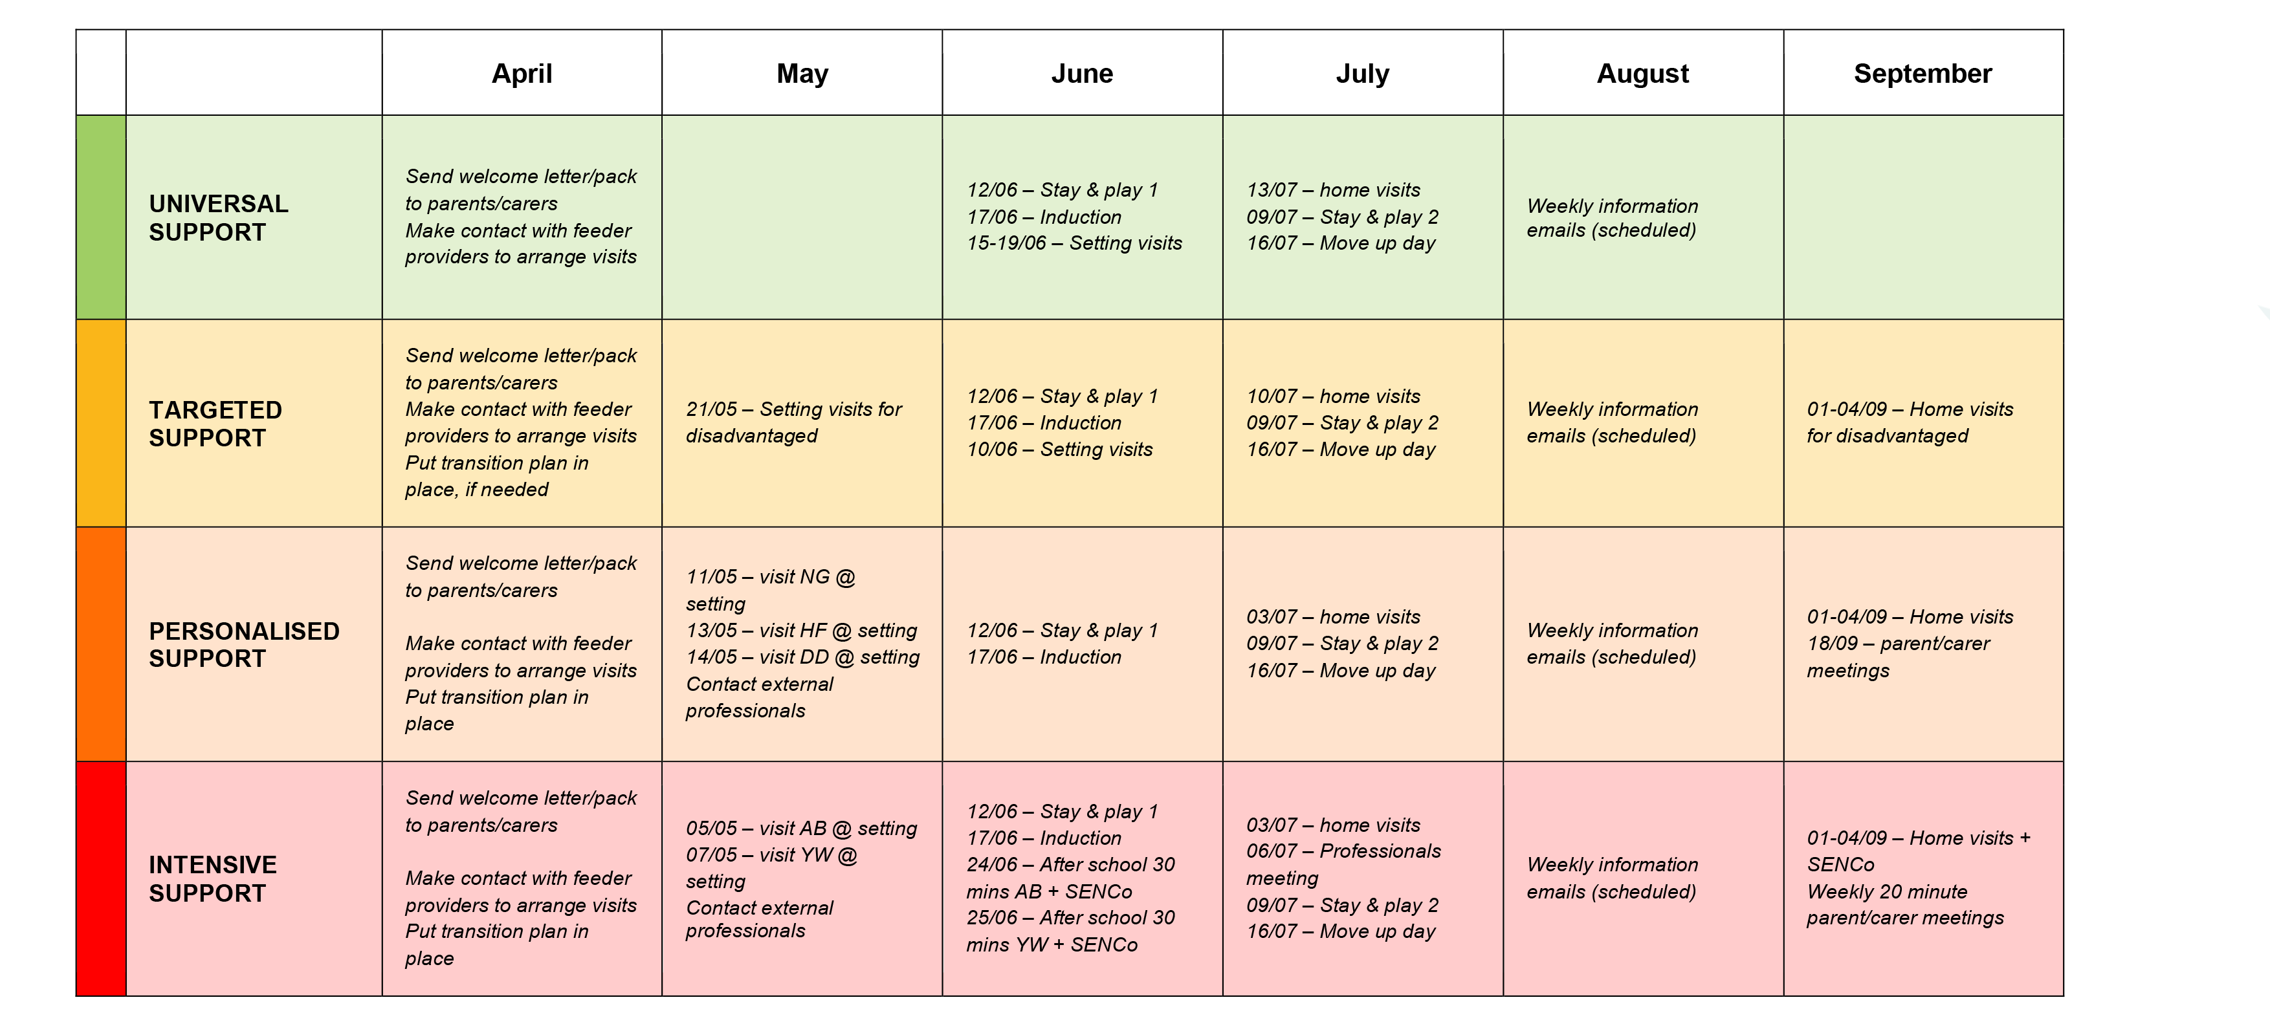

 |  | April | May | June | July | August | September
 | UNIVERSAL SUPPORT
 | TARGETED SUPPORT
 | PERSONALISED SUPPORT
 | INTENSIVE SUPPORT

